Demonstration

How to use Windows Subsystem for Linux with Microsoft Windows 10

**To enable WSL feature, do the following**

1. Launch Settings

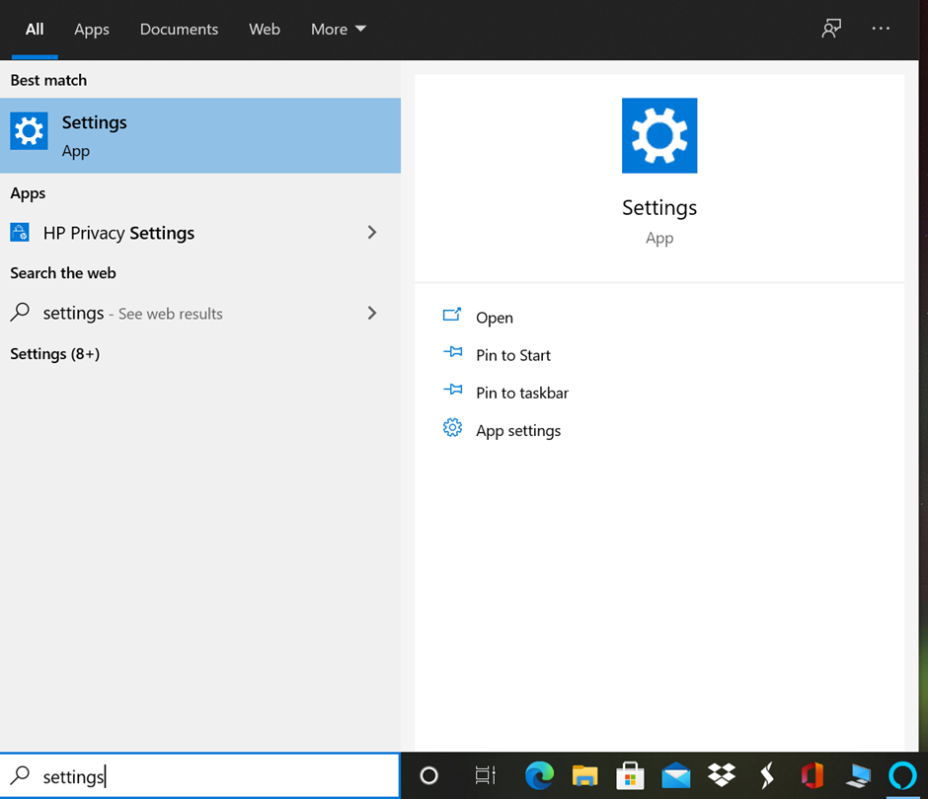

1. Search for feature

1. Go to more windows features

1. Check the feature to enable

**To Install Linux flavor, do the following:**

Here, I am using Ubuntu LTS to demonstrate the aim.

1. Launch Microsoft App Store

1. Search for Ubuntu. Install and create Linux user account (name and password)

1. Launch

1. Launch Shell and test basic functionalities

Demonstrated By:

Jigar Pandya

<https://linkedin.com/in/jigar-pandya>

Document last updated on 19th Nov, 2020.